Latin American Revolutions

Author: Melissa Williamson

Date Created: 3/21/2013

Subject(s): World History

Topic or Unit of Study (Title):
Unit 5: Monarchies and Revolutions
Latin American Revolutions

Grade Level: 9th

Materials: posters, makers, printed out pictures of each group’s revolutionary leader

Summary (and Rationale): The students will create posters in groups of one of the four Latin American revolutionary leaders and present them to the class.

I. Focus and Review (Establish Prior Knowledge): [15 minutes] What Spanish colonies were liberated during this time? Who lead each revolution? What influence did the American Revolution, French Revolution, and Enlightenment have on these events? Review vocabulary: peninsulares, L’Ouverture, “Liberator”, creole, mestizo

II. Statement of Instructional Objective(s) and Assessments:

Objectives | Assessments
Objective 1: When students are in groups, they will work together to create a poster. | Students will work in groups to create posters of one of the four major Latin American leaders during the revolutions and work together to draw pictures, share information, and understand the material.
Objective 2: When students are in groups, they will present to one another as experts on their leader. | Students will explain their leader to the rest of the class and take notes on the other leaders being presented. The students are teaching each other instead of learning from the book!

State the objective: [time]
Assessment: [time]

III. Teacher Input (Present tasks, information and guidance): [45 minutes]
- The teacher breaks the class into groups, ensuring that at least one or two students in each group fully comprehends the material to aid their group mates.
- Each group will be assigned one of the four Latin American revolutionary leaders:
  - Toussaint L’Ouverture
  - Miguel Hidalgo
  - San Martin
  - Simon Bolivar
- Each group will work to produce a poster at the end of class that includes the birth and death years, list and drawn pictures of countries liberated by them, five previously researched facts about each leader, and a printed photograph of them provided by the teacher.

IV. Guided Practice (Elicit performance): [12 minutes]
Each group will stand in front of the class and present their leader to the other students. The other students will take notes based on the poster, and everyone will be graded on presentation participation in addition to the required elements of the posters.

V. Closure (Plan for maintenance): [7 minutes]
The teacher will ask the students who they believe was the strongest leader and explain why in an open discussion amongst the class. Each group will then hang their poster on one of the four walls, with Simon Bolivar at the front, representing Venezuela in northern South America, Toussaint L’Ouverture on the right wall, representing Haiti in the northeast, San Martin at the back, representing Argentina in the south, and Miguel Hidalgo on the left wall, representing Mexico in the northwest.

VI. Independent Practice: [5 minutes]
Students will list three ways Latin America changed before and after the revolutions.

STANDARDS:

WH.5.3: Colonization, access to resources, consequences on indigenous cultures
WH.5.4: Investment in global exploration
WH.6.1: New ideas and theories of the universe on political thought and economic and social conditions
WH.6.2: Political Revolutions
WH.6.4: Effects of industrialism and urbanization on social and economic reform
WH.7.3: Economic and political rivalries, ethnic and regional conflicts, and nationalism and imperialism as underlying causes of war.

Plans for Individual Differences:
Students who prefer to work independently may do so, but will also present the poster by themselves. These students will still be responsible for the material presented by their classmates, and should take notes.
Also, students may be given specific responsibilities based on their learning style. For example, students who are more artistic may draw the country outlines and analytical students can be in charge of finding facts.

References (APA style):
Learn NC. World History North Carolina Essential Standards. http://www.learnnc.org/lp/pages/3432?ref=search

Making A Poster : Latin American Revolutions

Teacher Name: M Williamson
Student Name: ________________________________________

CATEGORY | 4 | 3 | 2 | 1
Required Elements | The poster includes birth and death years, countries liberated by chosen leader, and five or more researched facts. | The poster includes most of the following: birth and death years, countries liberated by chosen leader, and five researched facts. | The poster includes some of the following: birth and death years, countries liberated by chosen leader, and five researched facts. | Several required elements were missing.
Graphics -Clarity | Graphics are all in focus and the content easily viewed and identified from a distance. | Most graphics are in focus and the content easily viewed and identified from a distance. | Most graphics are in focus and the content is easily viewed and identified from a short distance. | Many graphics are not clear or are too small.
Knowledge Gained | Student can accurately answer all questions related to facts in the poster and processes used to create the poster. | Student can accurately answer most questions related to facts in the poster and processes used to create the poster. | Student can accurately answer about 75% of questions related to facts in the poster and processes used to create the poster. | Student appears to have insufficient knowledge about the facts or processes used in the poster.

Pictures of leaders to be printed out by teacher:
Simon Bolivar
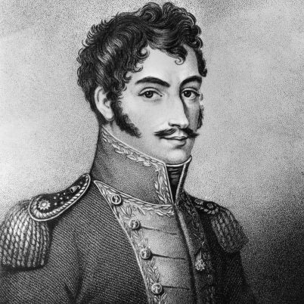

Miguel Hidalgo
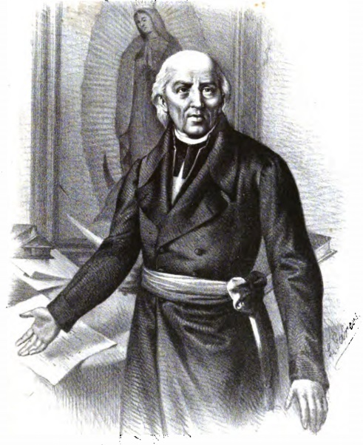

San Martin

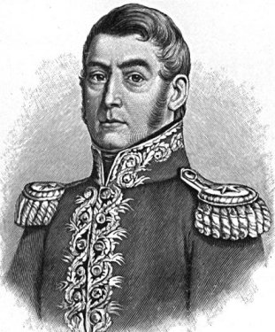

Toussaint L’Ouverture

