Those Who Have and Those Who Have Not

Author: Melissa Williamson

Date Created: 1/28/2013

Subject(s): World History

Topic or Unit of Study (Title):
Unit 5: Monarchies and Revolutions
Title: Those Who Have and Those Who Have Not

Grade Level: 9

Materials: Freshly popped popcorn

Summary (and Rationale): One-fourth of the class will receive popcorn while the remainder will not. The popcorn represents the wealth of the French nobility in the eighteenth century and the instructor represents King Louis XVI.

I. Focus and Review (Establish Prior Knowledge): [10 minutes] What were the major outcomes of the American Revolution? How did the Declaration of Independence influence the French? Review vocabulary terms: revolution, Industrial Revolution, political revolution, Scientific Revolution, estates, ancient regime

II. Statement of Instructional Objective(s) and Assessments:

Objectives | Assessments
Objective 1: When one-fourth of the class is given popcorn, the students will reflect on their experience by answering four questions. | Students will write about how they felt when they either received the popcorn or watched the rest of the class receive them. Did the “peasants” feel that they were treated unfairly? Did the “nobility” have a feeling of superiority? How did one group feel toward the other? How do they think the real peasants, clergy, and nobility felt?
Objective 2: When one-fourth of the class is given popcorn, the students will compare the instructor’s behavior to that of King Louis XVI. | The instructor will ask how their behavior was similar and different to King Louis XVI using a graphic organizer. The class will then come together and discuss, with the instructor writing the similarities on the board.

State the objective: [time]
Assessment: [time]

III. Teacher Input (Present tasks, information and guidance): [50-55 minutes]
- The smell of freshly popped popcorn often causes those nearby to nearly salivate. The popcorn will be placed at the front of the classroom as the students file in. No comment or reaction should come from the instructor as the students enter the room.
- Students will begin class by labeling a map of France, including the countries bordering it and the bodies of water, as well as major cities. As the students are engaged, the instructor will place small bowls of popcorn on the desks of one-fourth of the students. These students represent the nobility.
- After working on the maps for fifteen minutes using classroom computers, textbooks, and maps, the instructor will then introduce the French Revolution, including its ties with the American Revolution.
- After the required material is presented, a brief discussion will begin about how the peasants felt, but should only last for about three or four minutes.
- The estates system of 18th century France will then be presented by the instructor, including the aspects of the clergy, nobility, and peasants.
- As the activity comes to a close, the instructor will then pop another bag of popcorn and share it with the whole class as a pleasant gesture (and to prove that he/she is nothing like the arrogant, selfish King).

IV. Guided Practice (Elicit performance): [10 minutes]
The students will create graphic organizers that compare and contrast the instructor’s behavior to King Louis XVI during the French Revolution and the comparisons will be written on the board for visual aid.

V. Closure (Plan for maintenance): [5 minutes]
The instructor will ask the students what Louis XVI could have done differently to prevent the Revolution and they will answer when called on. Short class discussion.

VI. Independent Practice: [10 minutes]
Students will write a short paragraph about three of the major causes of the French Revolution. The causes must be identified and explained in a sentence or two and one major effect for each cause.
[no time limit]
Students will finish the maps that they did not complete in class and return for a homework grade.

STANDARDS:

WH.6 | 6.1: New ideas and theories of political thought and economic and social conditions
 | 6.2: Political Revolutions
WH.7 | 7.2: increase in economic and military competition
 | 7.3: Economic and political rivalries, regional conflicts, and nationalism and imperialism as underlying causes of war
 | 7.4: Social and economic conditions of colonial rule
 | 7.6: Economic crisis caused political and economic movements

Plans for Individual Differences:
Varying Questions—Changing the questions that the students must answer during discussion and the writing activity to accommodate each student’s learning needs based on what works best for them.

References (APA style):
Huntley, K. (n.d.). The French Revolution "Those who have and those who have not". Retrieved from http://www.learnnc.org/lp/pages/3432?ref=search
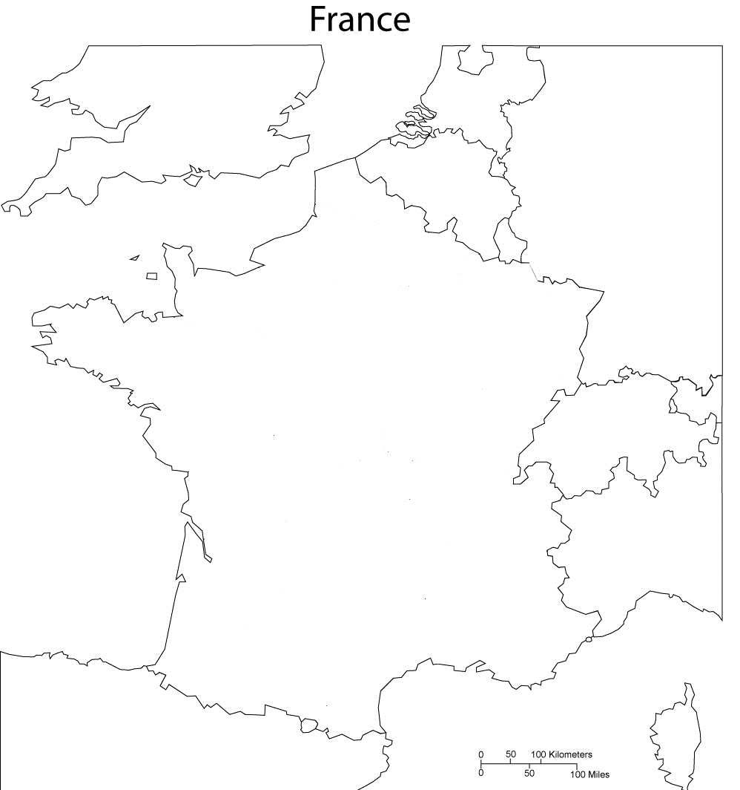Label the terms listed below:

Paris
Nantes
Corsica
Marseille
Versailles
Germany

Belgium
Netherlands
Austria
Switzerland
Italy
Spain
United Kingdom
Luxembourg
Mediterranean Sea
Bay of Biscay
English Channel

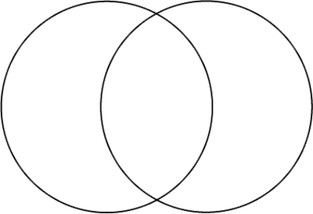
Ms. Williamson Louis XVI

